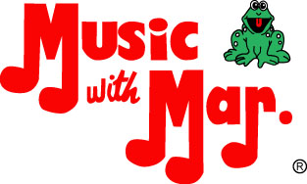
Play with Me; I’ll Learn with You
Maryann “Mar.” Harman
Founder of Music with Mar., Inc.
BA Music Ed; MA ED
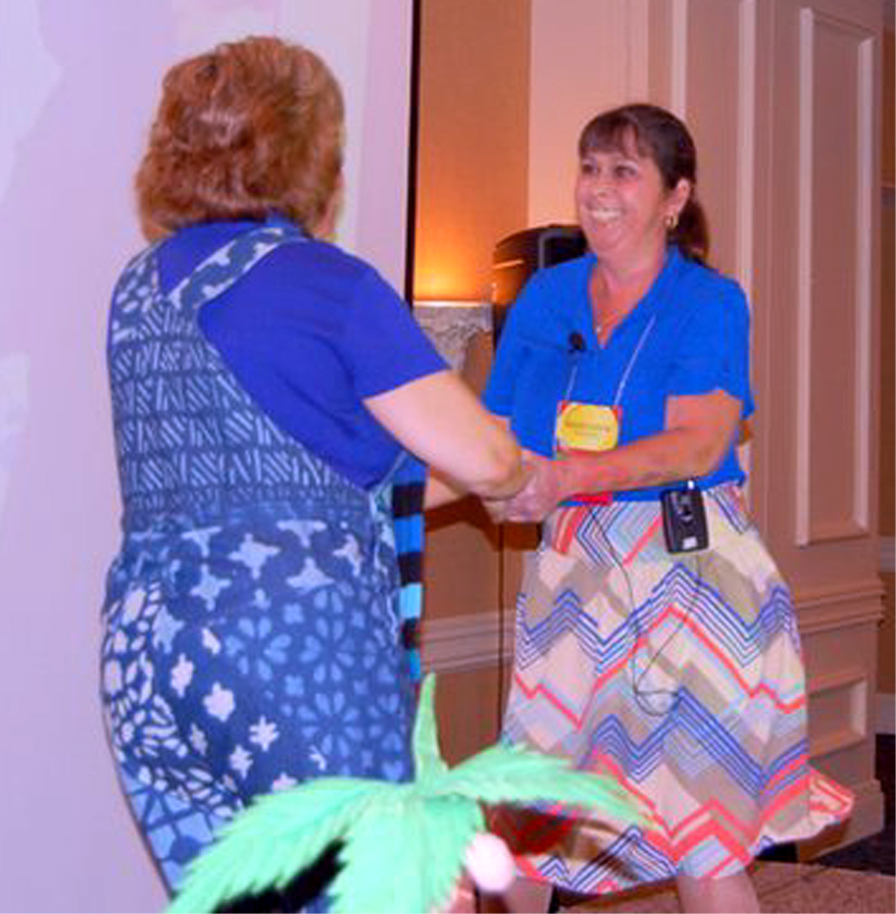Morning Strut
One song can do many things:
*Stimulate both sides of brain; produce endorphins
*Affect attitude
*Language – new vocab word “strut”
*Dancing (proper touch) Children don’t know manners-imitate them;
*Cross mid-section – need this skill to read/write
*“Whew!” oxygen – brain runs on oxygen and water
*Bouncing keeps steady beat
*Vestibular system must be activated to learn

“The 8th cranial nerve is the vestibulo-cochlear which comes from the inner ear mechanism. These connect through the Vestibular system to all the muscles of the body.” Dr. Carla Hannaford
It’s Early CHILDhood – FUN is part of the curriculum
Think ~ Not teaching the skill
Putting the tools in place to learn the skill
PROCESS
PRODUCT
So, if you can’t teach that day, don’t criticize. You – who you give them – is more important!

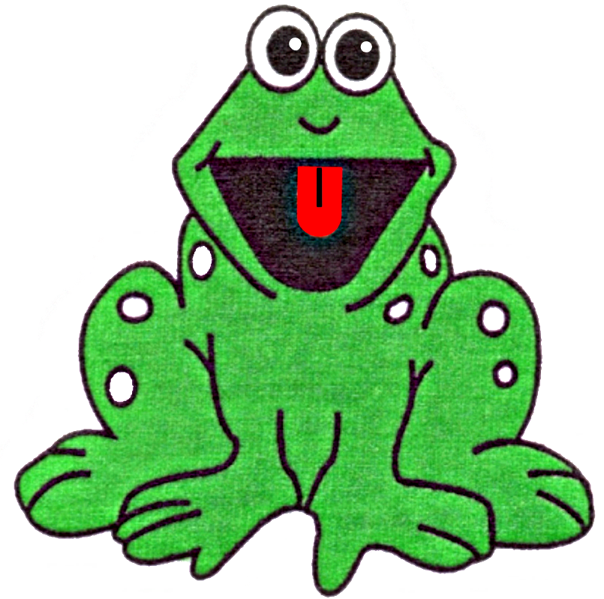
Having fun makes it easier to learn!
Helps the brain understand the rhythm of language!
Dance with your children!
I Like to Jump
*Body control
*Feeling internal rhythm
*opposites

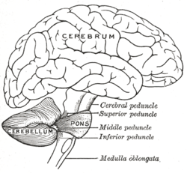BRAIN FACT
People who dance once a week decrease their chance of Alzheimer’s and dementia by 79%. (Verghese, 2003). Playing a musical instrument decreases it by 69%. (Churchill, 2002).

Dancing Disco Dogs (Singing in a Different Key)
*Children need to develop their motor skills.
*Social Interaction and Proper Touch
*Patterns

How Can I Move There? (Singing in a Different Key)
*Explore different ways to move – forward, backward, upwards, around
*Associate movement with an action or animal for a mental picture
*Exposure to Latin music

BRAIN FACT
It appears that a curriculum having limited arts exerts a negative effect on the development of critical cognitive competencies and personal dispositions. Burton, 90

Mr. Froggy (Bk + 4) Use of any puppet is helpful in getting children to speak out
Mr. Froggy came out one day. Said “Hi Miss Mar. Would you like to play?”
Miss Mar. said “Hi, frog. How do you do? Yes. I’d like to play with you.”
If class is small enough, sit in a circle. You hold the frog (or any puppet) first and everyone sings first line to the child to your right. Just that child sings back and everyone says “Yay!”. The frog is then passed to that person who turns to the person to their right. The song continues around the circle.
*Personality is developed by age 8
*Children need opportunities before 8 to build confidence
*Letting children be leaders is important
*Singing out in a safe environment builds confidence
*Vowel Sounds
*Release of endorphins – importance of laughter
*Can use various languages

ZYXs (Hear Me Sing)
*Step dancing is fun – no right way – just move
*Sequencing backwards

Cookie Mouth Sounds
*The six basic mouth sounds

*Use visuals
*Can make cookies and with “When the Doorbell Rang” by Pat Hutchins

I Like Apples (Tunes for Tiny Tots)
*We have four voices – whisper, talk, sing, shout. This drills on all four.
*It is more difficult to whisper than talk. It uses more muscles.
*Children must practice it.

Have children clap as well as say words. May use rhythm sticks.
I like apples; I like peas; (use whisper voice)
I like lentils; I like cheese. (Use talking voice)
When I eat them, my tummy says, “Yum!” (Use singing voice)
So everyday, I eat some! (Use shouting voice)

Mr. Froggy’s Friends’ ABCs (Mr. Froggy’s Friends’ ABCs)
*Indirect way to teach sentence structure
*Each letter has a subject, verb and object or adjective
*Have children make up own for their names or friend’s names
*Make your own ABC book

Five Hip Hoppy Frogs (Mr. Froggy’s Friends ABCs)
*Gets brain engaged and happy (or – HOPPY!)
*Croak for each frog. Awareness of number value
*Croaking for 5 takes longer than croaking for 1. (5 larger than 1)

Wide-mouthed Bullfrog (WMBF /Frog Glove) book by Keith Faulkner
*Children love interacting with story.
*If you don’t have the book, use pictures or puppets.
*Stay in one place or you become a moving target that is hard to follow.
*Children say with you “Hi. I’m a wide-mouthed bullfrog. I eat bugs.”
*For mouse, “Eek”. High pitch sounds energize the brain.
*For ‘hop, hop, hopped’, slap thigh 3 times. Vestibular system activated.
*Show the page where he makes his mouth small; help them understand the
lesson by saying, “He didn’t want to be a wide-mouthed bullfrog anymore.”
*Open the last page and have everyone throw up their arms and yell “Splash!”

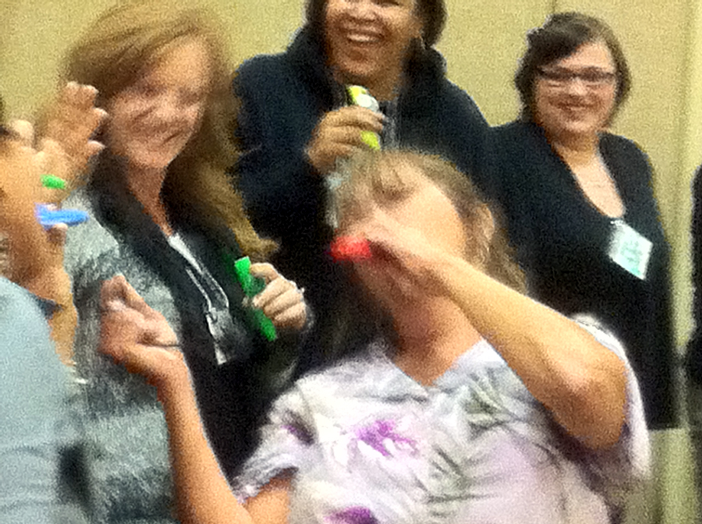 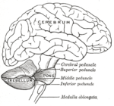BRAIN FACT Music is helpful when doing chores because it can reduce stress levels, heighten attention, enhance concentration, reinforce memory and stimulate motivation. (Campbell, 1997; Jensen, 2000)

Stress produces cortisol which in turn increases appetite. It can move fat from storage depots and relocate it to fat cell deposits deep in the abdomen. Cortisol also aids adipocytes (baby fat cells) to grow up into mature fat cells.
My Kazoo 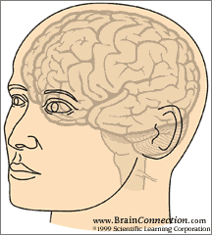
I love variety!
Kazoos help with:
- Inner voice development;
- Language development;
- Creativity;
- Confidence; and
- Self-esteem (I can play an instrument)
After using, keep kazoos in an open air container. This will keep germs from incubating. Write names on with permanent markers. Or, make your own!

Clean Up Blues (Music with Mar. / Bk + 4)
*Everything above
*Importance of chores
Move. Then, Stay Still
*Children cannot sit still until they practice

Changing songs that don’t “Feel” right
Monkeys Swinging in a Tree (Mr. Froggy’s Friends ABCs)
*Learn that by assessing behavior, you can change outcome
*Basic subtraction
Smart Woman (Music Makes It Memorable / Hear Me Sing)
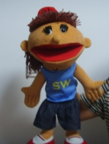
*Nutrition
*Food Groups
*Sequencing (can graph and chart)
*Scaffolding

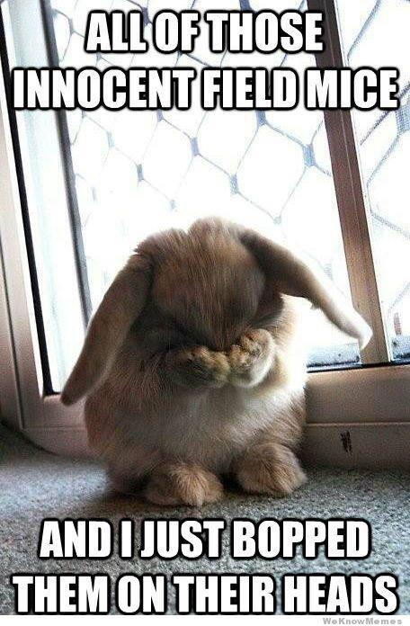Bunny Foo Foo (Bk + 4)
Traditional song; fun, nothing valuable taught. Here’s what we can do:
- Validate that the mouse is hurt;
- Tell rabbit “Look. The mouse is crying. You hit the mouse. Hitting hurts. You may not hit.”;
- Instruct the rabbit to say, “You’re crying because I hit you. Hitting hurts. I will not hit you again.” (You can teach “I’m sorry” but by itself, it means nothing.)
- Allow mouse to decide if she wants to play with the rabbit.
a. This teaches there are consequences to negative behavior;
b. Allows mouse to feel safe and in charge of choices; and
c. You do not need to play with someone just because they apologize

Up On Your Feet (Music Makes Me Wanna Move)
*Uses style children hear / like
*Counting, spelling
*Moving
BRAIN FACT
Afro Cuban / Salsa beats can benefit the brain by about 20% more than Mozart! (Parsons, 2006).

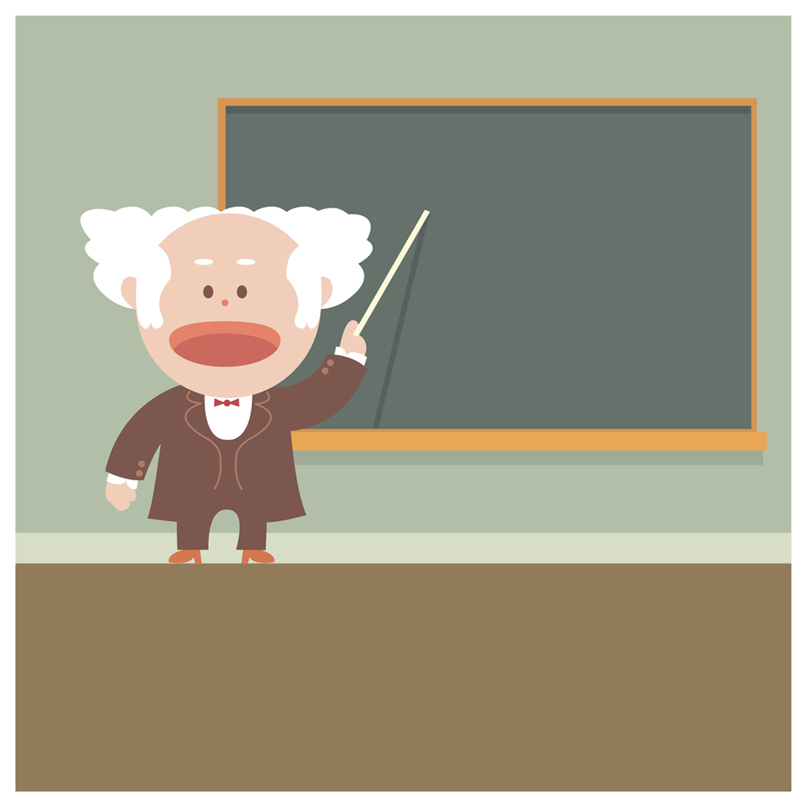
It becomes boring and ineffective when the same teaching pattern extends for a long period of time. Teachers need to switch things up to keep everyone involved. Different children learn different ways, but all children need to move!

Green, Yellow, Red (Mr. Froggy’s Friends’ ABCs)
*Learning about environment and how to follow community rules
*Identify color with action
*Use color on word with action – Reading Readiness

DISTUrbing FaCts
Problem with childhood obesity and diabetes
30% of US schoolchildren are overweight
Only 6% of High Schools offer daily PE in the US
Many schools have cut recess out of elementary school schedules
Games with rules – At this age, rules become important. Circle games helpful
All Around the Circle (Wide-mouthed Bullfrog)
All around the circle “I can do what you do” (2X)
Then stop right still “ “
Put your hands on your hip “ “
Let your right foot slip “ “
Then do it like this (person in center does motion; everyone imitates. That person than covers eyes, puts out pointing finger, turns in a circle and turns around while saying “1, 2, 3, 4. Turn around and pick someone,; we’ll do some more”
On the word someone, whomever is being pointed to, comes into the center

In and Out the Window (unFROGettable)
*Spatial temporal reasoning – the ability to understand your body in space and time
~– must be in place to understand numbers.
*Patterns and patterns with variation
*Following directions; listening
*Pre-planning; Working together
BRAIN FACT
Although test scores of use of music and no music may exhibit equal results, when memory of knowledge is compared later on, the students who learned through music and movement had better retention. (Altenmuller et al 1999).

Basic concept skills put in place through music and use of fingerplays (visual)

What Animal’s Missing (Mr. Froggy’s Friends’ ABCs)
*Deductive reasoning
*Let them switch animal’s order. Are they the same animals?

Five Hip-Hoppy Frogs (Mr. Froggy’s Friends’ ABCs)
*Croak for each frog. Awareness of number value
*Croaking for 5 takes longer than croaking for 1. (5 larger than 1)
Tell Me The Word (Mr. Froggy’s Friends’ ABCs)
*Basic things in the sky and their function
*Engaging music – positive statements

Going on a Shape Hunt (Mr. Froggy’s Friends’ ABCs)
*Instead of a bear hunt, look for shapes
~Can also do this with numbers, letters
*Making it fun engages frontal lobes, producing endorphins and oxytocin
*Use of music, movement and fun enhances ability to learn and retain
The Wheels on the Bus
*Keeps children actively involved in story with movement and sound
"When reading stories to young children, it is possible to replace the visual element by the pictures, upon which we now rely so heavily, with physical and verbal imitation.” Robert Munsch

Will You Hug Me? 
Touch must be
Important…
*Proper touch
*Positional words
BRAIN FACT Make that 3 Brain Facts ☺
Touch is 10 times more important than verbal or emotional contact. (Ackerman, 1990).
Humans can survive without seeing, smelling, tasting or hearing but will die from touch deprivation. (Chapin, 1920). Children who lack play and touch have 20 – 50% smaller brains. (Perry, 1998).
We all make mistakes. But to commit a wrong, to lower the dignity of a child and not be aware that the dignity has been impaired, is much more serious than the child’s skipping words during reading.

Clark E Moustakas
The Authentic Teacher

You Gotta Laugh (Start the Music)
*Vowel Sounds
*Release of endorphins – importance of laughter
BRAIN FACT
Music helps children explore emotions. The more emotions we expose them to (including uncomfortable ones ie fear, sadness), the more capable they are of dealing with them when they happen. Peter Alsop calls this "putting tools in their toolbox".
It’s Early CHILDhood – FUN is part of the curriculum
Think ~ Not teaching the skill
Putting the tools in place to learn the skill

Nothing Else (Start the Music)
*Scaffolding
*Sequencing and adding onto the sequence *Body control

Going Home (Start the Music)
*Rituals are important

Find the Gift (Mr. Froggy’s Family/Bk + 4) Reflective song about our role as teachers:
- Help children find their talents and develop them; and
- Help children feel good about their talents and strengths.

