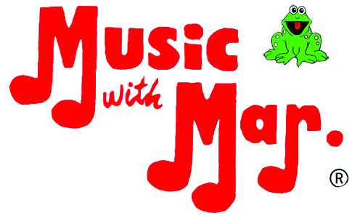 Release and Waiver of Liability Form

I, ______________________, will be participating in Music with Mar. Class at <FACILITY NAME> on <Mondays> at <10am> weekly. My child, <CHILD’S NAME(S)>, will be in attendance with me and I will be totally responsible for my child’s safety, health and well being.
I, recognize that there are risks involved in any activity and hereby assume all risk of injury, harm, damage or death in connection with my participation in this activity. I understand and agree that neither <FACILITY NAME> nor its trustees, officers, directors, employees, agents or representatives may be held liable in any way for any injury, harm, damage or death that may occur as a result of my participation in this activity. To the fullest extent permitted by law, I agree to save and hold harmless <FACILITY NAME> from any claim by myself, my estate, heirs, successors, assigns or other persons arising out of my participation in this activity.
I authorize <FACILITY NAME> through its trustees, officers, directors, employees, agents or representatives to render or obtain such emergency medical care or treatment for me or my child as may be necessary should any injury, harm or accident occur while participating in this activity.
I understand and acknowledge that <FACITILITY NAME does not provide health or medical insurance in connection with this activity and I agree that I will be financially responsible for any bills incurred as a result of medical treatment, including emergency medical treatment and/or transportation to a medical facility, in connection with my/my child’s participation in this activity.

Signature : ______________________________________________________
Printed Name : ___________________________________________________
Name(s) of Child(ren) : ______________________________________________
Date : _________________________

